**Directory Replicator User Guide**

1. Download the zipped folder from the EDEN sharepoint:

<https://reedelsevier.sharepoint.com/sites/LNGOTeamDept/NAEO_Statutes/production/Communication%20Hub/SitePages/Communication%20Hub%20-%20People%20and%20Places.aspx?RootFolder=%2Fsites%2FLNGOTeamDept%2FNAEO%5FStatutes%2Fproduction%2FCommunication%20Hub%2FDocuments%20%20People%20and%20Places%2FCI%20Tools%2FPython%20Scripts&FolderCTID=0x012000BC083BD35B3F004DB2A1B9FCEFC01C4C&View=%7BAF05E998%2D3535%2D4C33%2D918B%2D4FAEA3C551B2%7D>

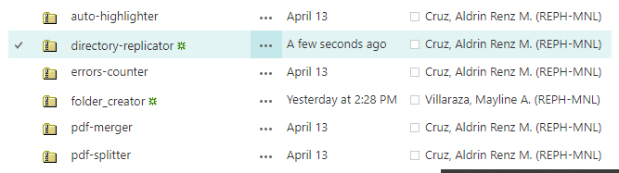

1. Extract/Unzip the files to any location you prefer (Script might not work if the files aren’t extracted or unzipped)
2. After extracting, you should see the following files in the folder:   
   A picture containing text, screenshot, font, line

   Description automatically generated
3. To use the replicator, move the “**build**” and “**replicate**” files in a folder where the new folders should be created.
4. Once ready, run the “**replicate**” script.
5. If you see the prompt below, just click “More info”, then “Run anyway”.  
   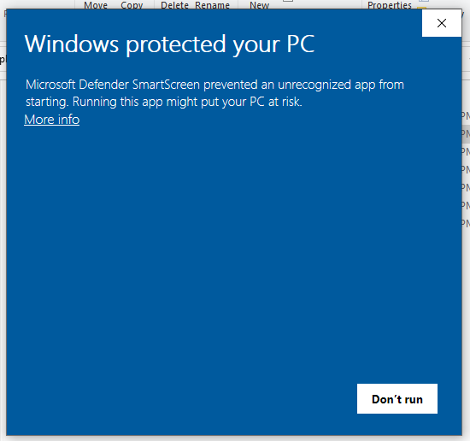
6. Wait for the terminal to open and prompt for the path:  
   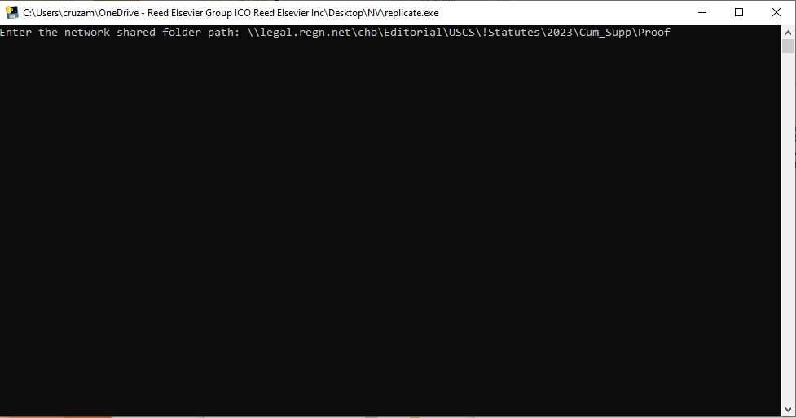
7. Paste the copied path and press the **Enter** key. Then type in either “FFE2” or “FFE3” depending on the format of Masterfile name. Press **Enter** key again.

1. It should start replicating the folder path provided. Please do not close the terminal or your computer while the script is running. It will indicate the progress of the script and display a message once complete. 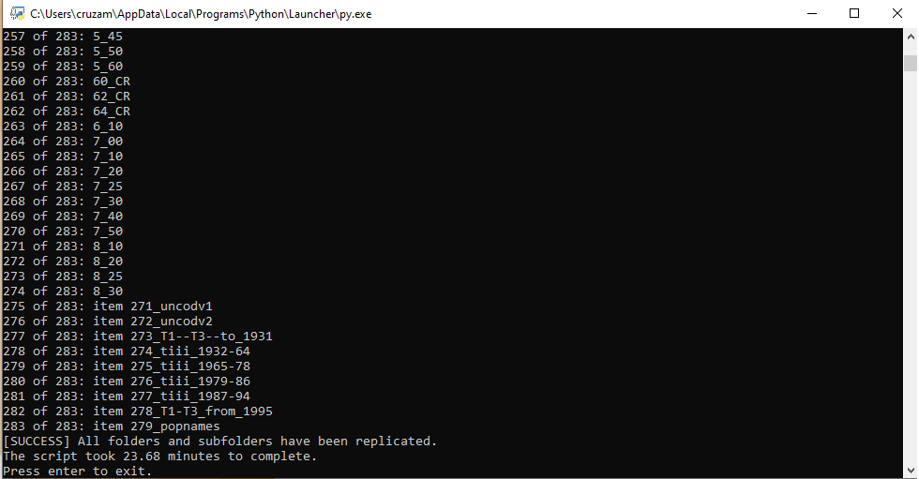

For any issues with this script, please contact me: Aldrin Renz Cruz (aldrinrenz.cruz@reedelsevier.com).